**ADDING AUTHORS AND EDITORS**

**To 700 and 100 fields**

Author:

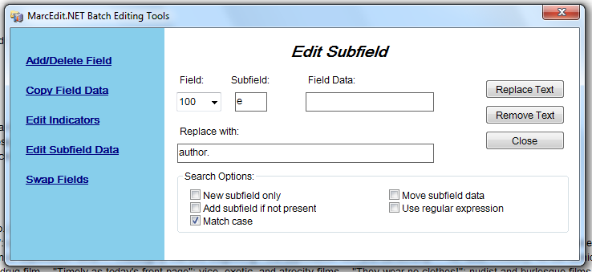

Editor:

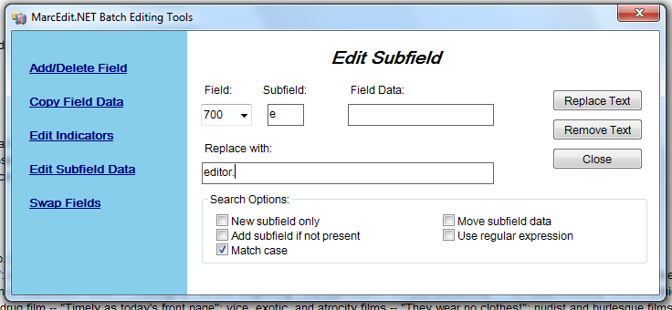

For eliminating the period and replacing a comma.

([a-z])([a-z])\.

$1$2,

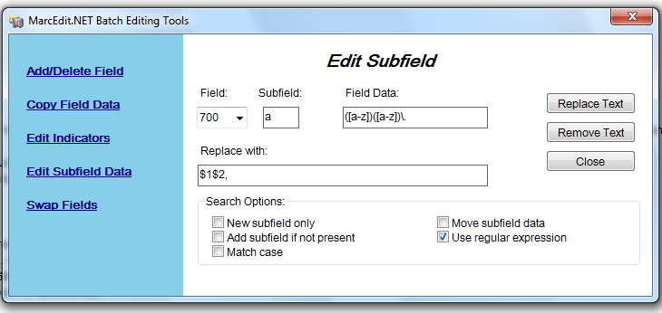

Do it for the 100 field as well.

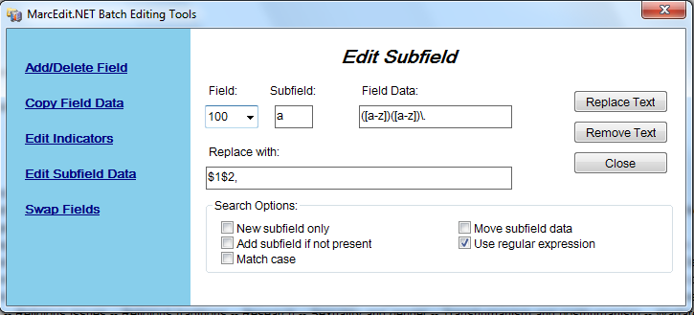

Find all for 100 and 700 fields to check format and also if 700 should be author or editor.

